Macro needed:

Receives a file

Change the font to a Hebrew one

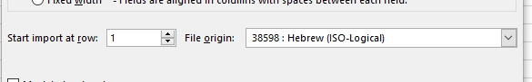

Brakes it up into columns – we now use the character ³

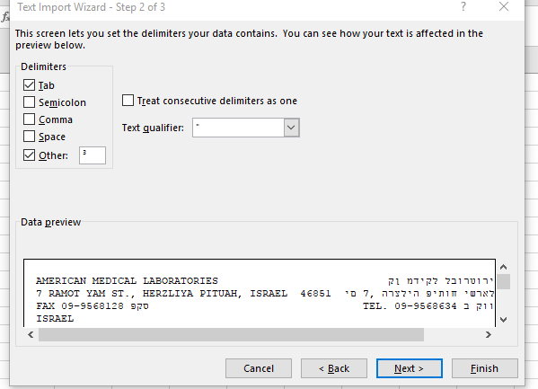

This is the result in excel :

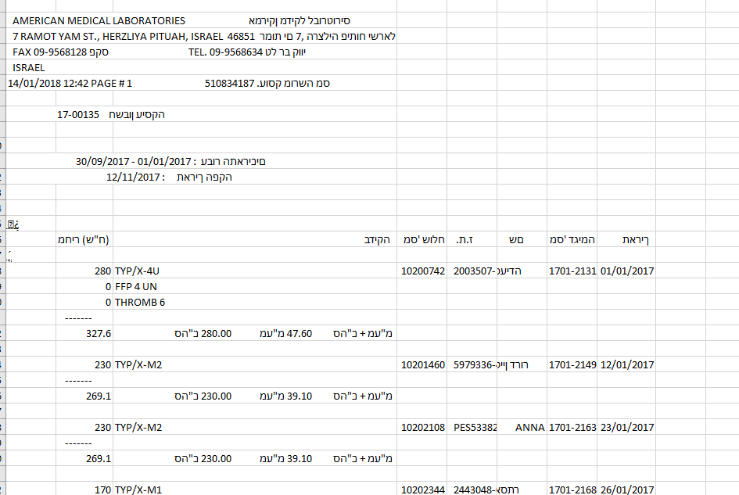

We just need the information in this part

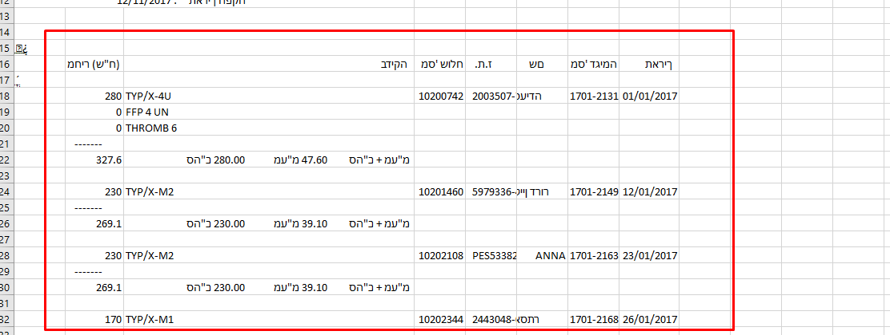

Scroll down and see that there are more “pages”

What we need to do now is to take the information and put it in a table.

I have translated the headers for your convivence

Each row is the same

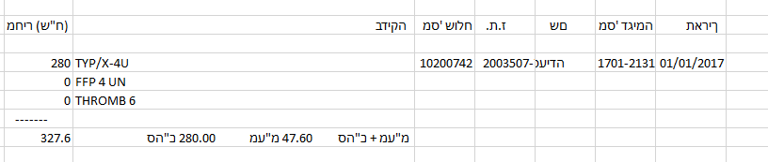

Date

Sample ID

Name

ID

Sender ID

Test name

Total Price

Text that says Total with VAT

VAT

Total

Total With VAT

How we want the end result to look like:



* If it has many tests names connect them and separate with |
* Headers will be in Hebrew

Another problem…

All the Hebrew text is reversed … We reverse it today using this Mcro

*Function Reversestr(str As String) As String*

*Reversestr = StrReverse(Trim(str))*

*End Function*

And then save and close this code, go back to the worksheet, and enter this formula: =reversestr(A2)

This is only relevant to the name in the data – since all other headers are fixed and we know their values

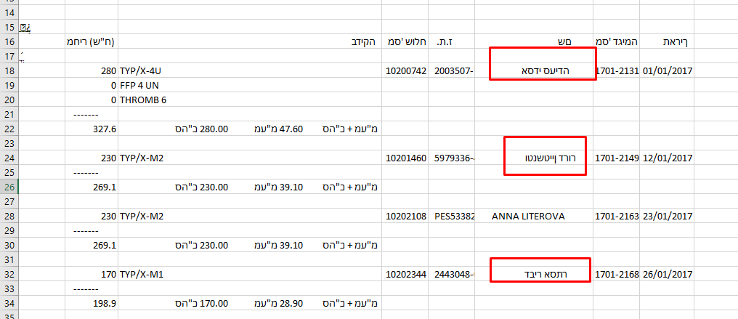

English Names are ok no need to reverse